**FOOD WASTE**

**Some facts from the Food and Agriculture Organization of the United Nations;**

* Roughly one third of the food produced in the world for human consumption every year — approximately 1.3 billion tonnes — gets lost or wasted.
* Food losses and waste amounts to roughly US$ 680 billion in industrialized countries and US$ 310 billion in developing countries.
* Industrialized and developing countries dissipate roughly the same quantities of food — respectively 670 and 630 million tonnes.
* Fruits and vegetables, plus roots and tubers have the highest wastage rates of any food.
* Global quantitative food losses and waste per year are roughly 30% for cereals, 40-50% for root crops, fruits and vegetables, 20% for oil seeds, meat and dairy plus 35% for fish.
* Every year, consumers in rich countries waste almost as much food (222 million tonnes) as the entire net food production of sub-Saharan Africa (230 million tonnes).
* The amount of food lost or wasted every year is equivalent to more than half of the world's annual cereals crop (2.3 billion tonnes in 2009/2010).
* Per capita waste by consumers is between 95-115 kg a year in Europe and North America, while consumers in sub-Saharan Africa, south and south-eastern Asia, each throw away only 6-11 kg a year.

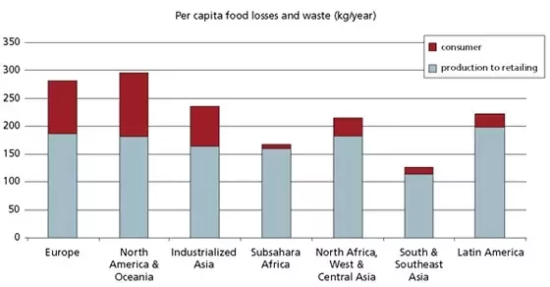

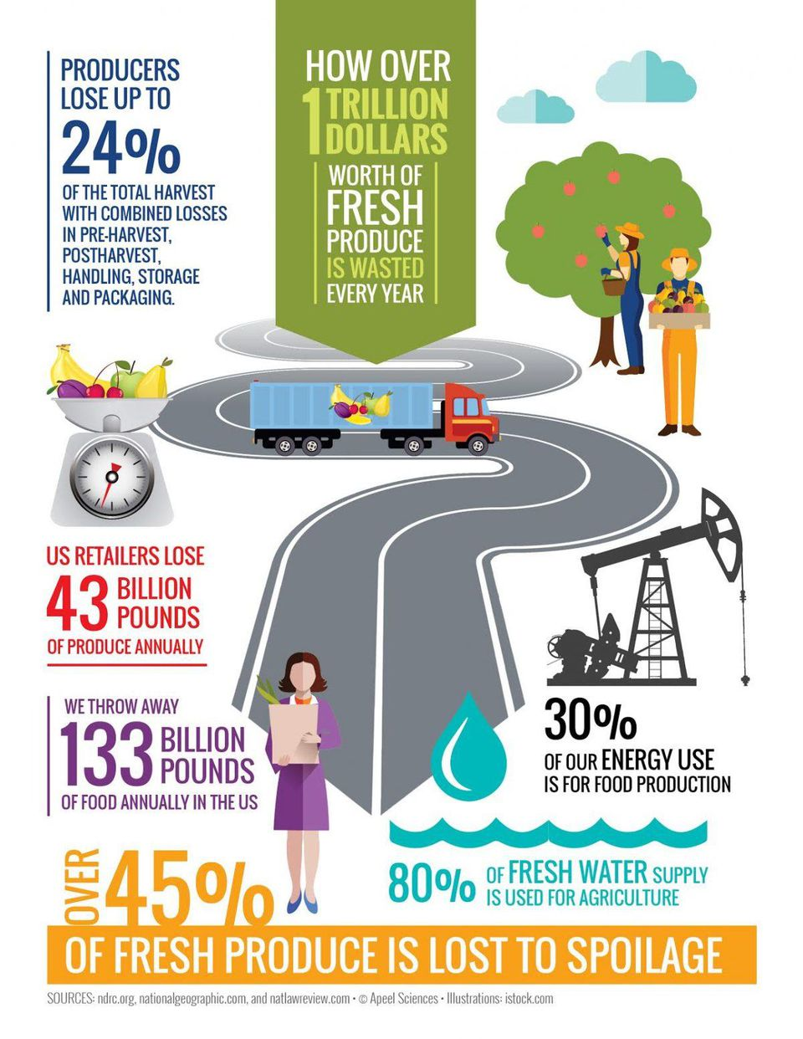

**Sources:**

<https://www.quora.com/How-much-food-do-we-waste-everyday>

<https://www.nytimes.com/2017/12/12/climate/food-waste-emissions.html>

<https://www.forbes.com/sites/michaelpellmanrowland/2017/08/28/food-waste-solution/#1e89f6fe4d17>

**Ideas from Droovi**

**Largest source - solid waste from municipalities**

* + **problem of uncontrolled decomposition which leads to environmental degradation (Landfill)- ---> ruining beautiful landscapes**
  + **waste from homes ---> people can do something about it as it is a very relatable thing**

**-----> show them that collective action can lead to a massive change in the bigger picture**

**-----> show effects on environment with time leap feature?**

**-----> effect on human health**

**-----> effect on world hunger eg: Africa ----> maybe simulate it in a way that players/ avatars go hungry or something**

**-----> effect on water scarcity -----> more meat = less water in park for example**

**-----> leading to conflict EG: social mechanism where players have to struggle for resources like land and water if other players make the bad choices (like using more meat)**

**Goal - Halve food waste by 2030**

**Other solutions:**

* **waste to energy power plants powered by biogas ----> possible idea for game? Collect trash ---> produced electricity**
* **- recycling, reduce the need to produce in large quantities ----> (need to change player behaviour)**

Plastic waste

* problems of production using toxic chemicals in the fossil fuel industry
* extreme pollution
* presence of micro-plastics in water, food which can harm humans

**WATER WASTE**

• According to the World Bank, only 0.5% of the world’s water is drinkable.

• 30-40% of the world will suffer from water shortages by 2040 (I don’t think retirement in a golfing community is going to be an option for too much longer)

• Agriculture accounts for 70% of our water use

• Energy companies also use a significant amount of our water supply as coolants

• The global middle class will increase from 1.8 billion to 4.9 billion by 2030. This increase will lead to a rise in consumption of freshwater.

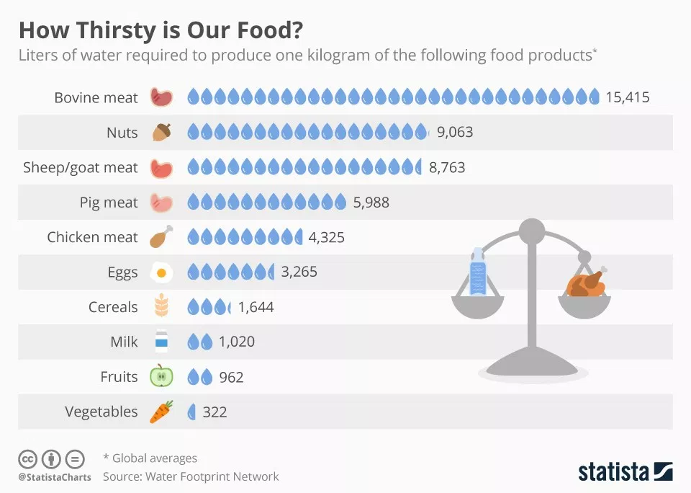

**Source:** <https://thedocskitchen.com/food-water-footprint/>

**WASTE IN BATHTUBS OF WATER**

The Smithsonian gives an explanation by translating the average amounts of wasted foods (pounds per year) into wasting bathtubs of water.

**Source:** <https://www.smithsonianmag.com/science-nature/how-trashing-food-wastes-water-too-180957239/>

**Waterfootprint ( Research Ray )**

**Under 1000 litre/kg**

A tomato is 214 litre/kg 214 litre/kg 0.2

1

Lettuce is 237 litre/kg 237 litre/kg 0.2

1

Cabbage is 237 litre/kg 237 litre/kg 0.2

1

Potatoes is 287 litre/kg 287 litre/kg 0.2

1

Cucumber or pumpkin is 353 litre/kg 353 litre kg 0.4

1

Orange is 560 litre/kg 560 litre/kg 0.6

1

A banana is 790 litre/kg 790 litre/kg 0.8

1

An apple is 822 litre/kg 822 litre/kg 0.8

1

Peach or nectarine 910 litre/kg 910 litre/kg 0.9

1

**Above 1000 litre/kg**

Maize is 1222 litre/kg 1222 litre/kg 1.2

2

Bread (from wheat) is 1608 litre/kg 1608 litre/kg 1.6

2

Pasta is 1849 litre/kg 1849 litre/kg 1.8

2

Dates is 2277 litre/kg 2277 litre/kg 2.3

2

Rice is 2497 litre/kg 2497 litre/kg 2.5

3

Groundnuts is 2782 litre/kg 2782 litre/kg 2.8

3

Olives is 3015 litre/kg 3015 litre/kg 3.0

3

Cheese is 3178 litre/kg 3178 litre/kg 3.2

3

Eggs is 196 litre for a 60-gram egg (3267) 3267 litre/kg 3.3

4

Chicken is 4300 litre/kg 4300 litre/kg 4.3

4

**Above 5000 litre/kg**

Goat is 5500 litre/kg 5500 litre/kg 5.5

5

butter is 5553 litre/kg 5553 litre/kg 5.5

5

Pig is 6000 litre/kg 6000 litre/kg 6

5

Sheep is 10400 litre/kg 14000 litre/kg 14

6

Beef is 15400 litre/kg. 15400 litre/kg 15.4

6

**CAUSES OF DEFORESTATION**

5 Main Causes:

**1 - Agricultural Expansion**

The conversion of forests into agricultural plantations is a major cause of deforestation. The increase in global demand for commodities, such as palm oil and soybeans, are driving

industrial-scale producers to clear forests at an alarming rate. Indonesia, the largest producer

of palm oil, was named the “Fastest Forest Destroyer,” in the 2008 Guinness World Records.

Even when efforts are made to replenish barren plantations, the depleted soil is not able to

produce the same biodiversity it once was.

**2 - Livestock Ranching**

Forest clearing for livestock ranching is another contributor of deforestation. Since 1990,

Brazil, a top exporter of beef, has lost an area of forest that is three-fourths the size of Texas.

A strong global demand for beef, supported by governments such as in Brazil, is expanding

this kind of deforestation.

**3 - Logging**

Logging, including illegal logging, is a driver of deforestation. In Indonesia, illegal logging

operations provide short-term income for people living on less than $1 a day. However, it

destroys the livelihoods of those who depend on the forest. Indonesia is one of the largest

exporters of timber, with about 80 percent of it being exported illegally. It is estimated that

organized criminals get between $10-15 billion dollars from illegal logging per year.

**4 - Infrastructure Expansion**

The 5,404 km Highway which runs from Brazil to Peru is a concern as the road cuts a strip

through the biodiverse Amazon rainforest. The road expansions often lead to logging and

illegal logging. The cleared land then attracts an influx of settlers and disturbs the peace.

**5 - Overpopulation**

Increase of global needs and wants, leading to expansion and deforestation

**Source:**

<https://www.onegreenplanet.org/animalsandnature/5-big-causes-of-deforestation-and-how-you-can-stop-it/>

**EXTRA INFO SOURCES:**

**How to think and act on climate change:**

<https://www.universityofcalifornia.edu/climate-lab>

**Prevent water waste:**

<https://www.mauicounty.gov/245/25-Things-You-Can-Do-To-Prevent-Water-Wa>

Nederland eet weer minder vlees:

<https://www.wakkerdier.nl/persberichten/nederlander-eet-weer-minder-vlees/?fbclid=IwAR0H3r29DCyZHMSMRbfE4rtbFtoFqU3xjhtWMfwrfGwRtoTKR_a3oqhDrPw>

<http://www.sdgfund.org/how-reduce-food-waste>